Cumann Lúthchleas Gael

## Seamróga an Tí Mhóir

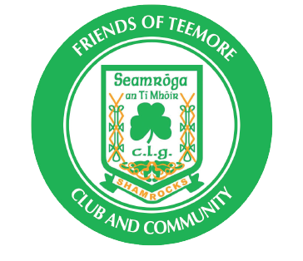

Email: [info@friendsofteemore.com](mailto:info@friendsofteemore.com)



**Cairde Tí Mhóir Membership Form: Please complete all sections highlighted in Yellow**

Please return the completed form via e-mail to [info@friendsofteemore.com](mailto:info@friendsofteemore.com)

Return the paper form to the member of the executive or fundraising team who was in touch with you.

|  |
| --- |
| Patron Forename and Surname: |
| Home Address and Postcode : |
| Contact Number and prefix: |
| Email address: |

Friends of Tí Mhóir Membership Option and payments:

Please tick the box for Membership subscription level:  Gold £ 40 €45 Silver £ 25 €30

1. Membership payment can be set up via Monthly Direct debit or Standing order
   * Our Sterling and Euro Bank Account details are shown below
   * When arranging your direct debit or standing order please use your full name to identify your individual membership for administration purposes.
2. Membership payments can also be made annually in one lump sum in Cash, Cheque or by Bank transfer.
   * Cheques if preferred can be made out to “Teemore GFC”
     + Gold subscription for 1 year £480, Silver £300
   * Please pass Cash or Cheque payments to a member of the executive or fundraising team who was in touch with you

Please tick the box below for the payment option you opted for:

Monthly Direct Debit/Standing order Lump sum by Cash ☐Lump sum by Cheque Lump sum by Bank Transfer



1st Chairde Jacket size: Please tick accordingly.

|  |  |
| --- | --- |
| Adult Male | Small  Medium  Large  XL  2XL 3XL  4XL |
| Adult Female | 8 10 12  14 16 18  20 |
| Child | 5-6  7-8  9-10  10-11  13 |

2nd Chairde Jacket size: Please tick accordingly.

|  |  |
| --- | --- |
| Adult Male | Small  Medium  Large  XL  2XL 3XL  4XL |
| Adult Female | 8 10 12  14 16 18  20 |
| Child | 5-6  7-8  9-10  10-11  13 |

In accordance with EU GDPR legislation Teemore Shamrocks GFC are obliged to inform you that by requesting the above information we are collecting and storing your personal information. The information we request is to enable us to provide membership to you, we do however require your explicit consent to collect and store your personal information. By ticking the consent box below please be aware that you agree to Teemore Shamrocks GFC collecting and storing your personal information. You may withdraw you explicit consent at any time (in writing).

Please tick below box

I explicitly Consent to Teemore Shamrocks GFC collecting and storing my personal information.

**Only Executive and Chairde Committee members will see this form**